1. Let’s wrap up with “how you should data modeling and structuring”.   
   Consider in which format you fetch data. You app or data scientists, how they need the data. You want to store the data in way that it is easy to fetch especially if you’re building an app or if you’re having a use case where you’re fetching a lot.

  
Do you optimize for write or read?

If you write data a lot, then you should avoid duplicate data.

If you read a lot, then some duplicates are ok but they must not change that often.  
This is all about embedded document or reference to document.  
  
  
How your data is related? One-to-one, one-to-many or many-to-many?  
This gives you indication for whether you want to go with embedded documents or references.   
Embedded: Duplicates can be created but keep in mind would you change it often or not?  


Would you embed 100 level deep which is limit by MongoDB.

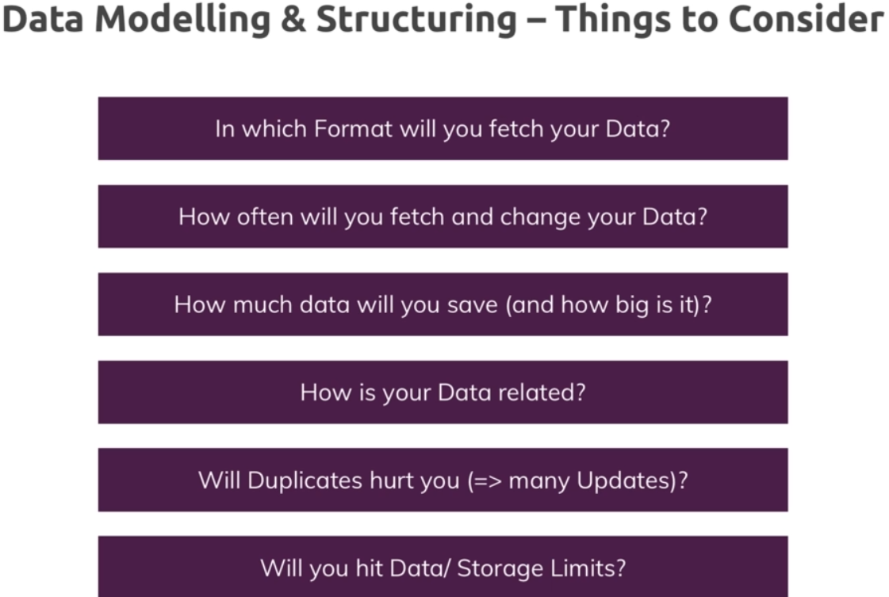

1. 